MT 172.2 Flowability of Granular Formulations after Accelerated Storage under Pressure*

SCOPE
The method is suitable for assessing the flowability of granular formulations after accelerated storage under pressure. The purpose is to demonstrate that the granules remain freely flowing after storage.

REASON FOR REVISION
The method was editorially revised as stand-alone method.
Inclusion(s) / up-date(s): Figure 1, accelerated storage conditions (Note 2), reference for test sieves, Procedure, Reporting.
Deletion(s): hardness of rubber mat, sieve (4.75 mm mesh size).
Test results obtained with MT 172.2 are equivalent to those obtained with MT 172.1.

OUTLINE OF METHOD
After accelerated storage under a defined pressure the sample is poured onto a sieve and the flowability through the sieve is determined. In case of any granules remaining on the sieve, a standardized tapping procedure is applied to determine the flowability after tapping.

APPARATUS
Balance, with an accuracy of at least ± 0.1 g
Beaker, 250 ml, approx. 5 to 7 cm internal diameter or similar (see Note 1)
Weight, fitting loosely in the beaker and with dimensions to apply an even pressure of 25 ± 0.5 g/cm² onto the surface of the sample; e.g. metal disc optionally plastic coated
Test sieve, approx. 20 cm diameter with 5 mm mesh size (ISO 565, ISO 3310-1), suitable collecting pan and lid
Set-up to control drop height, lab support stands with clamp holders and metal rods or similar, for example see Figure 1
Rubber mat, size min. 20 x 20 cm
Oven, temperature-controlled for the required temperature (± 2 °C) (Note 2)
Desiccator, without desiccant

PROCEDURE
Weigh about 50 g of the sample (initial weight m in [g]) into the beaker and spread it, without applying pressure, in an even layer of constant thickness. Place the weight on top of the sample in the beaker and store the beaker in the oven for the defined period of time at the specified temperature (Note 2). After the storage period, remove the beaker from the oven and allow it to cool to ambient temperature in a desiccator without any desiccant before removing the weight (Note 3).

Determine the weight of the empty sieve and place the sieve on top of the collecting pan.
Transfer the sample carefully onto the sieve. Observe whether the sample flows through the sieve spontaneously. If there are visually no granules left on the sieve (Note 4), report the result as “spontaneous”. This is equivalent to a flowability of 100 %. No further gravimetric determination is needed and the test is completed.

In case of any visible granules remaining on the sieve, proceed without weighing the residue: fit the lid on the sieve, lift the assembly of pan, sieve and lid by hand and allow the assembly to drop from a height of 1 cm onto the rubber mat. Lift and drop the assembly 5 times. Control the drop height using the set-up shown in Figure 1 or similar. If visually no granules remain on the sieve (Note 4), the test is completed. Report flowability after 5 liftings as 100 %.

Otherwise weigh the sieve and determine the residue on the sieve after 5 liftings in [g]. Re-assemble pan, sieve with residue and lid and repeat the lift-drop sequence 15 more times. If visually no granules remain on the sieve (Note 4), the test is completed. Report the flowability after 20 liftings as 100 %.

Otherwise weigh the sieve and determine the residue on the sieve after 20 liftings in [g].

CALCULATION
$$Flowability after n liftings in \left[\%\right]=100-100\frac{residue on the sieve after n liftings \left[g\right]}{m \left[g\right]}$$

m initial weight of sample [g]

REPORTING
If the sample freely flows through the sieve, report the result as “spontaneous”. The sample has a flowability of 100 %.

If any granules remain on the sieve but completely flow through the sieve after the first 5 lift-drop cycles, report the flowability after 5 liftings as 100 %.

If any granules remain on the sieve after 5 lift-drop cycles, report the flowability both after 5 and 20 liftings.

Note 1: Alternatively, a container of similar dimensions but with a removable base (e.g. made from plastic) may be used. After storage and cooling to ambient temperature, turn the container upside down, remove the base and carefully transfer the sample onto the sieve by pushing the weight downwards.
Note 2: If not specified otherwise, the test is carried out at 54 ± 2 °C for 14 days. The following, alternative conditions for accelerated storage can be applied:
50 ± 2 °C for 4 weeks
45 ± 2 °C for 6 weeks
40 ± 2 °C for 8 weeks
35 ± 2 °C for 12 weeks
30 ± 2 °C for 18 weeks
Consideration should be given to apply practical use conditions for the product.
Note 3: Alternatively, the filled beaker can be sealed in a bag for storage. In this case, it can be left to cool to ambient temperature in the bag without using a desiccator.
Note 4: For the visual evaluation, a reportable residue exists if granules or agglomerates remain on the sieve or are stuck between the wires of the sieve. Dust on sieve wires can be neglected.

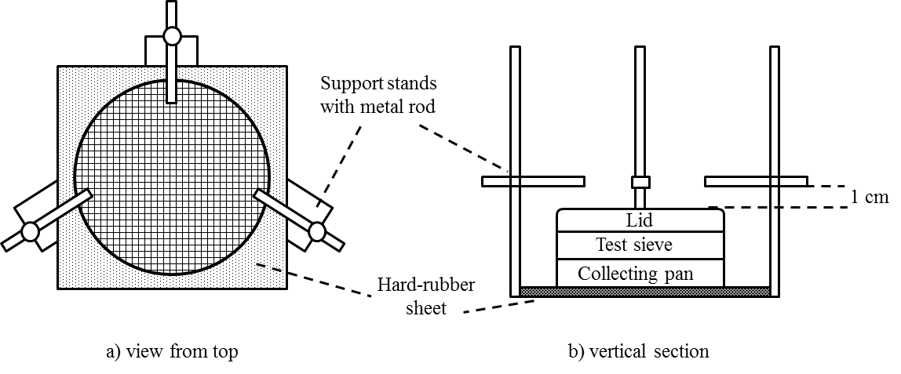

Figure 1: Sieve apparatus and set-up for controlling lifting height

